TRADE ASSISTANCE PROGRAMME
Background
Trade finance is a critical element for cross-border trade, and in many cases the movement of goods across borders, particularly in emerging markets, cannot occur without it. However, trade finance remains vulnerable to economic crisis despite being a low-risk asset class. In sync with the global trade demands and the growing need after the onset of the pandemic, there has been a felt need for a more robust trade finance programme.

With this backdrop, India Exim Bank has developed a new trade facilitation initiative ‘Trade Assistance Programme’ (TAP). Under TAP, India Exim Bank provides credit enhancement to trade instrument(s), thereby enhancing the capacity of commercial banks/financial institutions to support cross-border trade transactions involving markets where trade lines are constrained or where the potential has not been harnessed, and transactions may not materialize in the absence of such support. India Exim Bank also provides LC confirmation and negotiation for transactions involving untapped geographies and countries with higher risk perceptions.

Objectives
The key objectives of this programme include:
- Creating an enabling environment for counterparties in settlement of trade transactions;
- Support incremental exports by accessing identified untapped markets;
- Provide market entry mechanism, while enhancing the geographical coverage for exporters, including MSMEs;
- Provide risk coverage for challenging international trade transactions; and
- Enable local banks in target countries in establishing working partnerships with commercial banks in India.
Under the programme, India Exim Bank, by leveraging its experience and network of alliances, is building a network of partnerships among commercial banks in India and identified overseas banks that can seek risk mitigation support from India Exim Bank.

Offerings under TAP
TAP offers participating commercial banks in India partial or full guarantees to cover payment risk on banks from the emerging markets, and at the same time also facilitates Indian banks in meeting their commitment by fronting their guarantees, to encourage participation of Indian contractors to win/execute project in the overseas market. These credit mechanisms are transaction-specific and are offered by way of:
- LC confirmation/Negotiation
India Exim Bank confirms and negotiates Letters of Credit (LCs) issued by overseas banks (Issuing Bank), for export of goods/ services from India. India Exim Bank undertakes to make payment of the due amount to the Exporter, if the overseas Issuing Bank fails to make payment on the due date. Support is also extended for UPAS LC financing and confirmation/discounting of long tenor capex LCs.

- Standby Letter of Credit (SBLC)
India Exim Bank issues SBLC in favour of a Banks in India (Confirming Bank), which then confirms and negotiates LCs issued by overseas banks (Issuing Bank), for export of goods/ services from India. Under the SBLC, India Exim Bank undertakes to make payment to the Confirming Bank of the due amount, if the overseas Issuing Bank fails to make payment to the Confirming Bank. A Confirming Bank Agreement is entered into between India Exim Bank and LC Confirming Bank while Issuing Bank Agreement is entered into between India Exim Bank and overseas LC Issuing Bank, to undertake transactions under this mechanism.

- Risk Participation
If a Bank/Financial Institution is not able to partner with the importer’s bank, to support a trade transaction, due to insufficient exposure limits on the importer’s bank, India Exim Bank may consider sharing of the risk with the confirming/negotiating bank, under a Master Risk Participation Agreement, on select cases. Such risk participation under TAP is done for eligible transactions, covering export of eligible goods/ services from India. A Master Risk Participation Agreement is entered into between India Exim Bank and interested risk sharing bank to undertake transactions under this mechanism.

- Irrevocable Reimbursement Undertaking (IRU)
At the request of overseas Issuing Bank, India Exim Bank issues IRU in favour of Commercial Banks in India, under LCs issued by the Issuing Bank. With the comfort of IRU issued by India Exim Bank, Indian commercial banks may negotiate the export bills and can submit re-imbursement claim with India Exim Bank for settlement.

- Fronting of Guarantees
This product is catering to the requirements of Indian companies to cover their performance obligations abroad. Under this product, India Exim Bank issues counter guarantees in favour of overseas banks, to enable them to issue guarantee favouring local bodies, covering exports of goods/services from India. India Exim Bank issues such counter guarantees against the guarantee issued by Indian commercial banks, on behalf of their constituents in favour of India Exim Bank. Such fronting of guarantees could also be done in favour of Indian exporter/Bank for meeting financial obligations of the importer’s bank.

- Funded facilities
India Exim Bank extends Trade Loans to overseas partner banks for facilitating India’s trade. Eligible underlying transactions include funded LCs, buyer’s credit and any short term funded facilities extended by borrowing entity for supporting import of Indian goods and services and are outstanding in the books. Tenor of trade loan is up to one year. India Exim Bank also extends medium to long term Credit Lines to Overseas Financial Institutions and Regional Development Banks who act as intermediaries and on-lend to overseas buyers for import of equipment, goods and services from India.
List of Countries under TAP
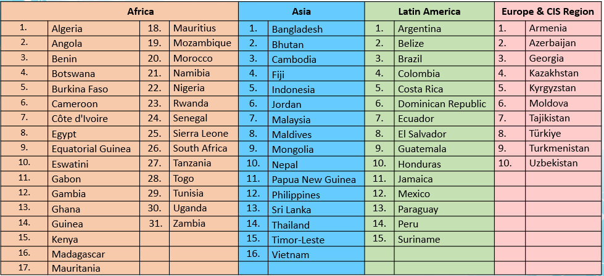
For further details, write to us at TAP@eximbankindia.in
India Exim Bank
Telephone: +91-22-22172308 / +91-22-22172404 www.eximbankindia.in

